Large Scale Distributed Systems:
Large scale means the system used in large scale, used by a lot of people, having a lot of data and distributed systems means the code executing the system are distributed in different locations for fault tolerance.
Design Patterns:
The general reusable solutions to common problems. There are some patterns, pricinciples and processes that enginners used in making large scale distributed systems and these patterns and design patterns.
Fault Tolerance:
Make sure none of the services fail in case of outage. if the comment service present in the servers available in India, and an outage appear to that server, then the solution to this problem will be distributed systems. We have servers available throughout the world, the server from other country will provide that service. We also have a lot of servers even in India itself, that servers will take the responsibility. There must be a data duplication in servers.
Extensibility:
How easy it is to add new features. Software should be highly extensible. E.g: if a user can send ‘hello’ msg to millions of people, now you wanna edit that system in such a way that user can also determine how many people have read that message, you should not build an entire new code, and test and deploy it. The previous should be extensible that you can easily make changes to that system to add new features.
Testing:
The designs that are built by senior engineers need to be tested before doing actual code. This is to check whether the design is feasible or not. You can also use different tools for that.
System Design actually deal with the backend part of large scale distributed systems, instedacof actually dealing with front end.
CONSIDER an example of a large scale distributed system, the system requirements are
- Showing live stream video
- Processing video
- Broadcasting
- Fail proof
- Advertisements
- Reactions
- Disclaimer
The primary requirement is showing live stream video, so we will pick that video from the creator and post it on a server and do the later part. The later part is actually the querying that video. Quering of that data is required because it is not possible to directly broadcast the video from the source device to millions of people, what if he is recording in 8K and sending this high quality video to users who are watching on mobile phone is unreasonable. So it is essential to 1st push the video on a server and then query it. The queries is done using APIs and these APIs are also tested beforehand.
Different other factors are also considered such as
- What of the database storing your videos crashes
- What if the firewall blocking your requests
- What if a piece of code starts misbehaving
- The challenge can also be a feature request
CONSIDER the diagram view of the above large scale distributed system.
The customer requests the data from server means the request moves from customer to server and then to the database. i.e, the database store data in the form of tables having columns such as video ID, video size, name etc (in this case). There is an API between the server and the database. Now the customers can be of any device such as phone, tablet, laptop etc. The customer send request to the server to get the video frame, this request moves to server using PAI. Let the API in this case is GET.video_frame(id, client_device, offset), this API get video frames from the database and return to customer. The API can also be of POST.comment(comment_id, author, video_id), which post data to database. VIMEO have same API for that. THIS IS JUST A ROUGH CONCEPT. The diagram is show below:
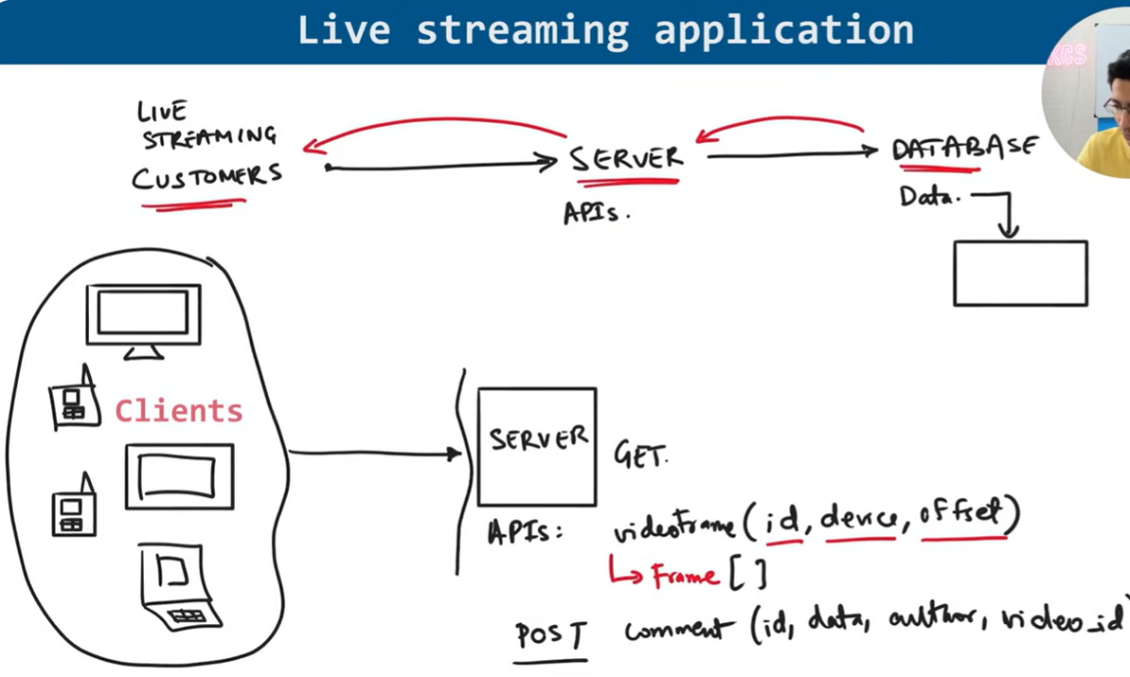
Now talk about the database design, the database in case of comments can be of a SQL database, where different tables are developed and they are conncetd using primary and foreign key etc etc.
NETWORK PROTOCOALS:
These are the set of rules that computers follows when communicating. Such as HTTP, FTP etc.
Stateless protocoals are those in which connection between client and server vanishes after each request. For each requet from client to server, the connection has to be reestablished. E.g: HTTP is a state-less protocoal, everything is present within the request., When I ask server to send videoframe of the next 10 seconds from the current time of video using HTTP, it is not possible. We have to write in request that send video from 10 minuite 20 seconds to 10 minute 30 seconds because server don’t know what is the current time of the video.
On the other hand, in stateful protocols, connection remain established between client and server. If you are watching video at time 10 minutes 10 seconds and you ask server to send me the video frame of next 10 seconds, the server can easily give you that because the server has the information about your current state.
Advantage of stateless is that everything is kept simple, if the server crashes there is no memory that lost.
For video, there must be protocoals that are designed specifically for videos, because in video there are some other factors as well such as what if I am using a mobile device that cannot bear that high resolution and what kind of video I am requesting. For example, if I am requesting a live video lecture, I must have a reliable protocoal to send each packet reliably. TCP is a reliable protocoal and UDP is real time efficient protocoal. For video, WebRTC protocol is good for trabsferring data from server to client.
Means, NETWORK PROTOCOALS are also very important when designing large scale systems.
CHOOSING A DATASTORE: koi bhi database use kr lo, hr ek ka apna protocal h, but now it does not matter what is the protocoal behind which database. This video data can easily be stored in SQL and other databases as well but the videos are in the form of files so we should prefer to use file systems such as HDFS or S3 because they are little bit cheap as compared to SQL and other databases. HDFS (Hadoop Distributed File System): A system that stores large files across multiple servers in a cluster, designed for fast processing of big data. It splits files into blocks, replicates them for fault tolerance, and is best for on-premises or local networks. Amazon S3 (Simple Storage Service): A cloud-based storage service where you can store and retrieve files (objects) from anywhere over the internet. It’s highly scalable, durable, and managed by Amazon, making it ideal for backups, media, and distributed applications.
HDFS and S3 both are not databases that require strict format to store data and strict quering principles. They just store data in the form of different files. This can be .txt files or .pdf files etc etc, but files should be large.
For video, WebRTC protocol is good for trabsferring data from server to client. But the protocoal for sendinf video from the source to the database should be highly reliable because we don’t want any information to be lost. We want everything to store in the database, therefore we will use RTMP (real time media protocoal). Because if some information lost from showing to client (e.g: if he is watching a live stream video, if some info is lost then OK) is Ok but losing information to storing to database is a serious concern.
HOW TO TRANSFER raw data that we record from the database to the customers in different formats such as 720 p, 1080 p and so on (MAP REDUCE PATTERN)?
We will use a transformation system, which take video and convert it into diffenret resolutions such as 1080 p, 720 p, 360 p and 144 p etc. These resolutions are defined in Product Requirement Document (PRD) as there are some customers who want video in 4K because they wanna see in TV. Anyways, 1st step will be divide the video into different segments such as segments of 10 seconds each and transfer each segment into different resolution programs. May be a specific program will be parraallely running in all 5 resolution programs. Moreover, this transformation system can also transfer the video in different formats suich as if the clien is using android phone there are only specific formats that are acceptable and so on. Most common format is h.264, Netflix has its own formats. Means, overall map reduce pattern is like dividing the video into different segments and transferring it into different programs i.e, they can either change format of video, can compress the video and change the quality of video etc etc, all programs are running in different servers and at the end you have different products, all these products store in a database.
In practice: For a platform like Netflix, each transformation (transcoding) job runs on different servers in a distributed system to handle millions of videos efficiently.

